# Automated User Interface Testing Notes

02/22/2017

## Software

The open source software package that The iFish Group (IFG) utilized for frontend testing is the following:

<http://www.sikuli.org/>

## Demo

We have posted a demo of the IFG prototype at the following location. The demo should be viewable online for the at least the next 60 days (until mid-April 2017).

<https://fccdl.in/508hjrInb>

## Description

This tool allows us to test any graphical element and interact with any object via visual detection to perform automated validation testing.

## User Story Test Description

For this user test, we are going to perform the following tasks:

1. Verify Text
2. Verify Create Account link
3. Verify Sign-In
4. Verify logo
5. Verify that the screen defaults to the Home screen
6. Verify that links exist for all of the Menu items
7. Click on the Earthquake Menu item
8. Verify that the map of California is shown and does not display any data points
9. Verify the “Earthquakes from last 7 days” link
10. Click on the “Earthquakes from last 7 days” link
11. Verify that the “Earthquakes from last 7 days” link is highlighted
12. Verify that “All” button exists
13. Verify data points on map

Figure 1 – Home Screen of Application (Steps 1-7)

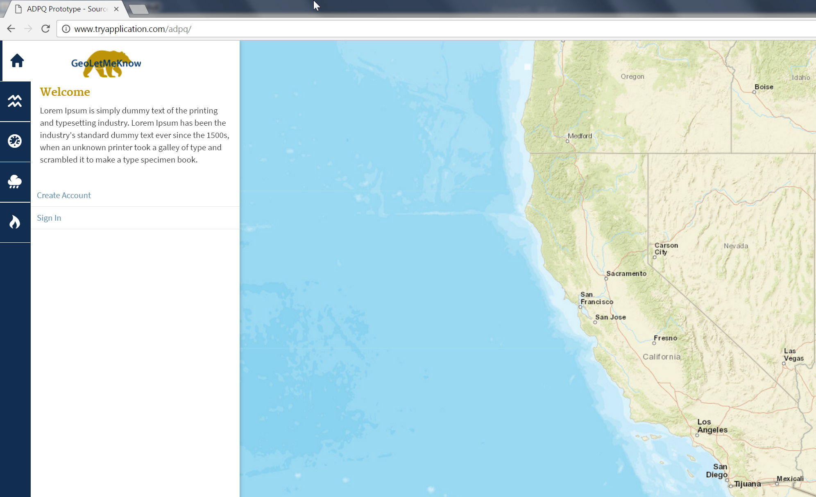

Figure 2 – Click on Earthquakes Link (Steps 8-10)

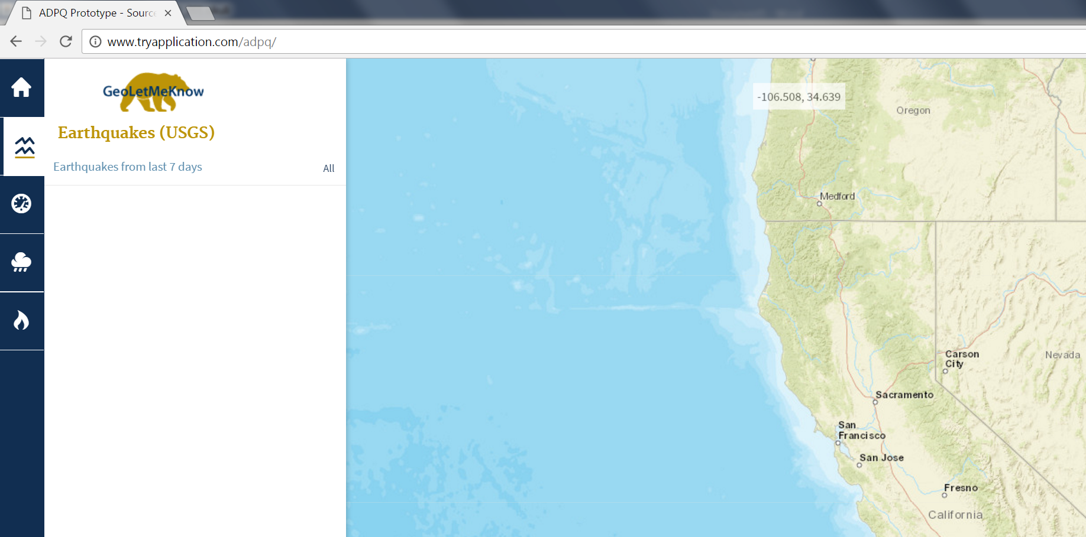

Figure 3 – View API Data on Map

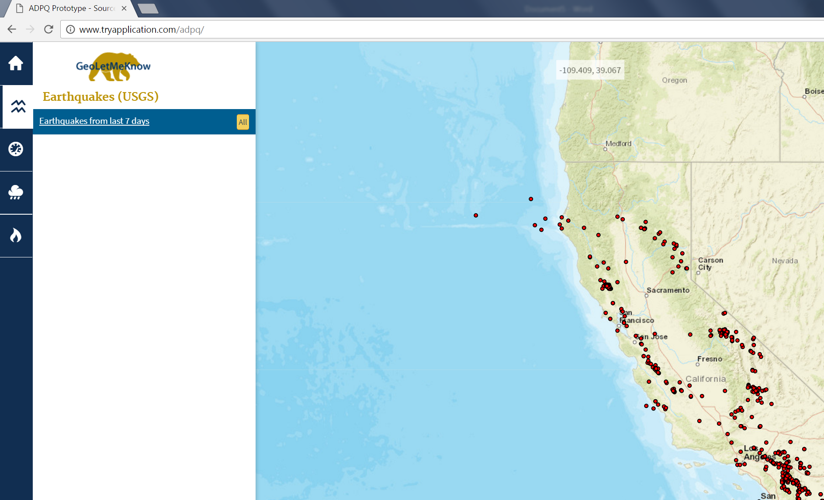

**Automated Testing Development Environment**

This is the development environment that allows us to quickly design, test, and deploy automated User Interface (UI) testing. All testing is performed to verify user story requirements.

